FORM 2

THE PATENT ACT, 1970 (39 of 1970)

COMPLETE SPECIFICATION

TITLE OF THE INVENTION

Multimodal Hazard Assessment & Response System for an Underground Mine Robotic Rover

Applicant

Marri Laxman Reddy Institute of Technology and Management,
Dundigal, Hyderabad-500043, Telangana, India

&

MLR Institute of Technology,
Dundigal, Hyderabad-500043, Telangana, India

The following specification particularly describes and ascertains the nature of this invention and the manner in which it is to be performed.

1. FIELD OF THE INVENTION
The present invention relates generally to robotic systems for underground mine safety, inspection and hazard assessment. More particularly, the invention relates to a multimodal robotic rover system configured to acquire heterogeneous sensing information from an underground mine environment, correlate information obtained from multiple sensing modalities for determining mine hazard events, associate the determined hazard events with a position or relative position of the robotic rover, and provide an obstacle-based movement response. The invention further relates to wireless transmission and remote presentation of the determined hazard events, associated location information and corresponding multimodal sensing information for supporting remote inspection and monitoring of hazardous or post-accident underground mine regions.

2. BACKGROUND OF THE INVENTION AND RELATED PRIOR ART
Underground mining environments may present hazardous conditions including accumulation of gases, abnormal temperature conditions, reduced visibility, fire or thermal anomalies, structural obstructions, and other conditions that may endanger personnel. Such conditions can become particularly difficult to assess during emergencies, accidents, or operations in areas where direct access by mine personnel may expose the personnel to additional risk.
Conventional mine safety and monitoring arrangements commonly employ fixed monitoring equipment, individual sensing devices, manually operated inspection equipment, or combinations of environmental sensors for acquiring information relating to selected mine conditions. Although such arrangements can provide useful measurements, they may provide limited information regarding the spatial occurrence of a detected hazardous condition and may not provide a mobile, location-associated view of the underground environment.
Robotic systems have also been proposed for underground mine inspection, monitoring and rescue operations. Such systems may incorporate combinations of cameras, gas sensors, thermal sensors, acoustic sensors, environmental sensors, obstacle-detection sensors, communication units and remote-control or monitoring arrangements. Multimodal sensing and sensor-fusion techniques have further been employed to improve detection of environmental conditions and persons in underground environments.
However, the use of multiple sensing modalities on a robotic platform does not, by itself, ensure that information acquired from different sensing modalities corresponds to the same mine region, sensing interval or sensing event. Independent presentation of sensor measurements may also require an operator to manually interpret information from different sources when determining whether a hazardous condition exists.
Further, detecting a hazardous condition without associating the detected condition with the corresponding position or relative position of the mobile sensing platform can limit the usefulness of the information for remote inspection and subsequent assessment of the affected region. Similarly, obstacle detection and rover movement control may be implemented independently from hazard assessment, thereby limiting the integration of environmental assessment with mobile operation.
Accordingly, there remains a need for an integrated underground mine robotic rover system capable of acquiring heterogeneous sensing information, correlating information from at least two different sensing modalities corresponding to a common mine region, sensing interval or sensing event, determining a mine hazard event from the correlated information, and associating the determined hazard event with a position or relative position of the rover corresponding to acquisition of the relevant sensing information.
There is also a need for such a system to determine a movement response based on obstacle information acquired during rover operation and to wirelessly transmit the determined hazard event, associated location information and corresponding multimodal sensing information to a remote monitoring interface.
The present invention addresses these requirements by providing a multimodal robotic rover system in which heterogeneous sensing, multimodal hazard assessment, hazard-location association, obstacle-based movement response, wireless communication and remote presentation are functionally integrated for underground mine inspection, hazard monitoring and assessment of hazardous or post-accident regions.

3. OBJECTIVES OF THE INVENTION
The objectives of the present invention are:
- To provide a mobile robotic rover for underground mine inspection and hazard assessment.
- To integrate gas, temperature/humidity, visual, thermal, acoustic and proximity sensing on the rover.
- To correlate information from multiple sensing modalities for determining mine hazard events.
- To associate detected hazard events with the rover's position or relative position.
- To provide obstacle-based movement response during rover operation.
- To continuously update hazard assessment using subsequently acquired sensing information.
- To wirelessly transmit hazard, location and multimodal sensing information to a remote monitoring interface.
- To provide remote monitoring and assessment of hazardous or post-accident mine regions while reducing personnel exposure.

4. SUMMARY OF THE INVENTION

The present invention provides a multimodal robotic rover system (100) for underground mine hazard assessment and remote inspection. The system comprises a mobile robotic rover (110), a multimodal sensing unit (120), a processing and intelligent decision unit (130), a multimodal hazard assessment unit (140), a hazard-location association unit (150), a navigation and response unit (160), a wireless communication unit (170), and a remote monitoring interface (180).

The multimodal sensing unit (120) comprises a plurality of heterogeneous sensing modules including a gas sensing module (121), a temperature and humidity sensing module (122), a visual imaging module (123), a thermal imaging module (124), an acoustic sensing module (125), and a proximity sensing module (126), configured to acquire information from the underground mine environment.

The processing and intelligent decision unit (130) receives the sensing information and correlates information acquired from at least two different sensing modalities corresponding to a common mine region, sensing interval, or sensing event. Based on the correlated sensing information, the system determines a mine hazard event or abnormal condition.

The hazard-location association unit (150) associates the determined mine hazard event with a position or relative position of the mobile robotic rover (110) corresponding to acquisition of the sensing information used for determining the hazard event. As the rover moves through the underground mine environment, subsequently acquired sensing information may be correlated to update the hazard assessment and associated position or relative position.

The navigation and response unit (160) determines a movement response based on obstacle information acquired by the proximity sensing module (126), thereby supporting obstacle-aware movement of the mobile robotic rover (110).

The wireless communication unit (170) transmits the determined hazard event, associated position or relative position, and corresponding multimodal sensing information to the remote monitoring interface (180). The remote monitoring interface (180) presents the hazard event, associated location information, and supporting sensing information to a remote operator for monitoring and assessment.

The system thereby integrates heterogeneous sensing, multimodal hazard assessment, hazard-location association, obstacle-based movement, wireless communication, and remote monitoring to support inspection of hazardous or post-accident underground mine regions while reducing initial personnel exposure to such regions.

5. DETAILED DESCRIPTION OF THE INVENTION WITH ACCOMPANYING DRAWINGS

5.1 Overall System Architecture
Referring to FIG. 1A, a multimodal robotic rover system (100) is provided for underground mine hazard assessment and remote inspection. The system (100) comprises a mobile robotic rover (110), a multimodal sensing unit (120), a processing and intelligent decision unit (130), a multimodal hazard assessment unit (140), a hazard-location association unit (150), a navigation and response unit (160), a wireless communication unit (170), and a remote monitoring interface (180). The mobile robotic rover (110) is configured to move through an underground mine environment and operate as a mobile sensing platform. The rover (110) carries the multimodal sensing unit (120) for acquiring information from locations within the underground mine instead of relying solely on fixed monitoring points.

5.2 Multimodal Sensing Unit
The multimodal sensing unit (120) comprises a plurality of heterogeneous sensing modules mounted on or associated with the mobile robotic rover (110). The sensing modules acquire different types of information from the surrounding underground mine environment.

5.2.1 Gas Sensing Module
The gas sensing module (121) is configured to acquire information indicative of a gas-related condition within the underground mine environment. The acquired gas-related information is provided to the processing and intelligent decision unit (130) for assessment according to predetermined operating criteria, decision rules, sensor cross-checks or other suitable decision mechanisms.
The gas sensing module (121) may be selected according to the gases intended to be monitored and the sensing technology implemented in a particular embodiment.

5.2.2 Temperature and Humidity Sensing Module
The temperature and humidity sensing module (122) is configured to measure temperature and relative humidity surrounding the mobile robotic rover (110). The acquired environmental information is supplied to the processing and intelligent decision unit (130) and may be used independently or in correlation with information acquired by other sensing modules.

5.2.3 Visual Imaging Module
The visual imaging module (123) is configured to acquire visual information of the underground mine environment. The visual information may include images or video of mine passages, structures, objects, obstacles and surrounding conditions.
The visual information may be processed locally and/or transmitted through the wireless communication unit (170) for presentation to a remote operator through the remote monitoring interface (180).

5.2.4 Thermal Imaging Module
The thermal imaging module (124) is configured to acquire thermal information from the surrounding environment. The thermal information may be used to identify temperature differences or thermal anomalies that may not be readily apparent from ordinary visual information. The thermal information may further be correlated with environmental, visual, gas-related or other sensing information for multimodal hazard assessment.

5.2.5 Acoustic Sensing Module
The acoustic sensing module (125) is configured to acquire acoustic information from the underground mine environment. The acoustic information may be analyzed to identify sound events or acoustic patterns indicative of a person's presence, a distress-related event, or another relevant environmental event. When a relevant acoustic event is identified, the processing and intelligent decision unit (130) may associate the event with the corresponding rover position or relative position and other sensing information acquired during the corresponding sensing interval or event.

5.2.6 Proximity Sensing Module
The proximity sensing module (126) is configured to detect obstacles located within or near a travel path of the mobile robotic rover (110). The acquired obstacle information is supplied to the navigation and response unit (160).
When an obstacle is detected, the navigation and response unit (160) determines a movement response, which may include modifying a movement direction, movement state or path of the mobile robotic rover (110).

5.3. Processing and Intelligent Decision Unit
The processing and intelligent decision unit (130) receives sensing information from the multimodal sensing unit (120). The sensing information may include gas-related information, temperature information, humidity information, visual information, thermal information, acoustic information, obstacle information and, where available, rover movement and position information. The processing and intelligent decision unit (130) may perform preprocessing, information association, comparison, correlation and decision operations on the acquired sensing information. The unit (130) is configured to associate sensing information acquired from different sensing modalities with a common mine region, sensing interval or sensing event. Such association may be performed using one or more of acquisition time, rover movement state, rover position or relative position, sensing interval, or correspondence of the sensing information to a substantially common region of the underground mine environment. The processing and intelligent decision unit (130) correlates information obtained from at least two different sensing modalities associated with the common mine region, sensing interval or sensing event. Based on the correlated information, the unit (130) determines whether a mine hazard event or abnormal condition is present. The decision mechanism may employ predetermined thresholds, rules, sensor cross-checks, decision logic or a machine-learning-based decision mechanism, depending on the implementation.

5.4. Multimodal Hazard Assessment Unit
The multimodal hazard assessment unit (140) receives correlated sensing information from the processing and intelligent decision unit (130) and determines a mine hazard event or abnormal condition based on the correlated information. The correlated information may comprise one or more combinations of environmental information, visual information, thermal information, acoustic information and gas-related information. The use of multiple sensing modalities enables information associated with a common mine region, sensing interval or sensing event to be considered together rather than relying exclusively on an isolated sensor measurement. The determined hazard event may include an indication of the detected or assessed hazardous condition together with corresponding sensing information.

5.5. Hazard-Location Association Unit
The hazard-location association unit (150) associates a determined mine hazard event with a position or relative position of the mobile robotic rover (110).
The position or relative position corresponds to the location of the rover when the sensing information used for determining the hazard event was acquired. The location information may be obtained from an available positioning or localization arrangement, rover movement information, relative-position information, or another suitable localization mechanism.
The invention does not require a particular underground positioning technology. Accordingly, the associated location may be represented as an absolute position where such positioning is available or as a relative position within the mine environment.
The resulting hazard event may therefore be represented together with its corresponding rover position or relative position.

5.6. Navigation and Response Unit
The navigation and response unit (160) receives obstacle information from the proximity sensing module (126).
When the proximity sensing module (126) detects an obstacle within a relevant detection range, the navigation and response unit (160) determines a movement response for the mobile robotic rover (110).
The movement response may comprise changing the movement direction, modifying the movement state, stopping the rover, or modifying a travel path. The rover may subsequently resume movement while continuing to acquire sensing information from the multimodal sensing unit (120).
Thus, sensing and mobile operation are performed concurrently to support obstacle-aware movement within the underground mine environment.

5.7. Wireless Communication Unit
The wireless communication unit (170) is configured to transmit information acquired and/or processed by the mobile robotic rover (110) to a remote monitoring interface (180).
The transmitted information may comprise one or more of sensor measurements, determined hazard events, associated position or relative-position information, rover status information, visual information, thermal information, acoustic information and alert information.
The communication unit (170) may transmit processed hazard information together with corresponding multimodal sensing information so that a remote operator can assess the detected condition using supporting information from different sensing modalities.

5.8. Remote Monitoring Interface
The remote monitoring interface (180) provides a remote operator with information received from the mobile robotic rover (110).
The interface (180) may present live visual information, thermal information, environmental measurements, acoustic information, rover status, rover position or relative position, detected hazard events and alerts.
The hazard indication may be presented together with the associated position or relative position of the rover and corresponding multimodal sensing information.
Accordingly, the remote operator can obtain a synchronized representation of the rover's operating condition, detected mine hazards and supporting sensing information without requiring immediate physical access to the inspected region.

5.9. Functional Operation
Referring to FIG. 1B, the operation of the system (100) begins with acquisition of heterogeneous sensing information by the multimodal sensing unit (120).
The acquired sensing information is provided to the processing and intelligent decision unit (130), where information from at least two different sensing modalities corresponding to a common mine region, sensing interval or sensing event is correlated.
Based on the correlated information, the multimodal hazard assessment unit (140) determines a mine hazard event or abnormal condition.
The hazard-location association unit (150) then associates the determined hazard event with the position or relative position of the mobile robotic rover (110) corresponding to acquisition of the relevant sensing information.
During movement of the rover, the proximity sensing module (126) continuously acquires obstacle information. The navigation and response unit (160) uses the obstacle information to determine an appropriate movement response.
The wireless communication unit (170) transmits the determined hazard event, associated position or relative position and corresponding multimodal sensing information to the remote monitoring interface (180).
The remote monitoring interface (180) presents the determined hazard event and supporting sensing information to the remote operator.

5.10. Updated Sensing During Rover Movement
As the mobile robotic rover (110) moves through the underground mine environment, subsequently acquired sensing information may be correlated and assessed in the same manner.
The processing and intelligent decision unit (130) may therefore update the hazard assessment when additional sensing information is acquired. The corresponding hazard-location association may also be updated based on the position or relative position of the rover at the time of subsequent sensing.
This enables the system to provide an evolving representation of mine conditions along the rover's movement path.

5.11. Acoustic Rescue Assistance
In an embodiment, the acoustic sensing module (125) may acquire acoustic information that indicates a possible person's presence, call for assistance, distress-related sound or another relevant acoustic event.
The detected acoustic event may be correlated with the position or relative position of the rover and, where available, supporting visual, thermal or environmental information.
The resulting event may be transmitted to the remote monitoring interface (180) to assist a remote operator in assessing a possible rescue-related situation.

5.12. Hazardous and Post-Accident Inspection
The mobile robotic rover (110) may be deployed for inspection of hazardous, inaccessible or post-accident regions of an underground mine.
The rover can acquire multimodal sensing information while entering or operating within such regions, thereby allowing a remote operator to receive information regarding environmental conditions, visual conditions, thermal conditions, acoustic events, obstacles and detected hazard events.
The system thereby supports remote assessment of potentially hazardous mine regions and can reduce the need for immediate personnel exposure during initial inspection.

BRIEF DESCRIPTION OF THE ACCOMPANYING DRAWINGS
FIG. 1A illustrates an overall system architecture of the multimodal hazard assessment and response system (100) for an underground mine robotic rover, showing the mobile robotic rover (110), multimodal sensing unit (120), processing and intelligent decision unit (130), multimodal hazard assessment unit (140), hazard-location association unit (150), navigation and response unit (160), wireless communication unit (170), and remote monitoring interface (180).
FIG. 1B illustrates a functional flow of the system (100), showing acquisition of heterogeneous sensing information, processing and correlation of information from at least two sensing modalities, determination of a mine hazard event, association of the hazard event with a rover position or relative position, obstacle-based movement response, wireless transmission, and remote presentation of the determined hazard event and corresponding multimodal sensing information.

We Claim:
1. A multimodal robotic rover system (100) for underground mine hazard assessment and remote inspection, comprising:
a mobile robotic rover (110) configured to move through an underground mine environment;
a plurality of heterogeneous sensing modules (120) mounted on the mobile robotic rover (110), comprising a gas sensing module (121), a temperature and humidity sensing module (122), a visual imaging module (123), a thermal imaging module (124), an acoustic sensing module (125), and a proximity sensing module (126);
a processing and intelligent decision unit (130) configured to receive sensing information from the plurality of heterogeneous sensing modules (120) and correlate information acquired from at least two different sensing modalities corresponding to a common mine region, sensing interval or sensing event to determine a mine hazard event;
a hazard-location association unit (150) configured to associate the determined mine hazard event with a position or relative position of the mobile robotic rover (110) corresponding to acquisition of the sensing information used for determining the mine hazard event;
a navigation and response unit (160) configured to determine a movement response based on obstacle information acquired by the proximity sensing module (126);
a wireless communication unit (170) configured to transmit the determined mine hazard event, the associated position or relative position and corresponding multimodal sensing information; and
a remote monitoring interface (180) configured to present the determined mine hazard event together with the associated position or relative position and the corresponding multimodal sensing information to a remote operator.
2. The system (100) as claimed in claim 1, wherein the processing and intelligent decision unit (130) correlates at least two of environmental information, visual information, thermal information, acoustic information and gas-related information associated with the common mine region, sensing interval or sensing event for determining the mine hazard event.
3. The system (100) as claimed in claim 1, wherein the processing and intelligent decision unit (130) determines the mine hazard event based on at least one of a predetermined threshold, decision rule, sensor cross-check, decision criterion or machine-learning-based decision mechanism applied to the correlated sensing information.
4. The system (100) as claimed in claim 1, wherein the acoustic sensing module (125) is configured to acquire an acoustic event indicative of a person's presence or a distress-related event, and the hazard-location association unit (150) associates the acoustic event with the position or relative position of the mobile robotic rover (110).
5. The system (100) as claimed in claim 1, wherein the navigation and response unit (160) modifies at least one of a movement direction, movement state or travel path of the mobile robotic rover (110) in response to obstacle information acquired by the proximity sensing module (126).
6. The system (100) as claimed in claim 1, wherein the wireless communication unit (170) transmits the determined mine hazard event together with at least one corresponding visual, thermal, environmental or acoustic sensing information, and the remote monitoring interface (180) presents the transmitted information together with the associated position or relative position.
7. The system (100) as claimed in claim 1, wherein the processing and intelligent decision unit (130) receives subsequently acquired sensing information during movement of the mobile robotic rover (110) and updates the determined mine hazard event and the associated position or relative position based on the subsequently acquired sensing information.
8. The system (100) as claimed in claim 1, wherein the mobile robotic rover (110) is configured for remote inspection of a hazardous or post-accident region of the underground mine environment, whereby initial assessment of the region is performed remotely to reduce exposure of personnel to the region.
9. A method for multimodal underground mine hazard assessment using a robotic rover (110), comprising:
acquiring environmental, visual, thermal, acoustic and obstacle-related sensing information using a plurality of heterogeneous sensing modules (120);
correlating information obtained from at least two different sensing modalities corresponding to a common mine region, sensing interval or sensing event;
determining a mine hazard event based on the correlated sensing information;
associating the determined mine hazard event with a position or relative position of the robotic rover (110) corresponding to acquisition of the sensing information used for determining the mine hazard event;
determining a movement response based on obstacle information acquired by a proximity sensing module (126);
transmitting the determined mine hazard event, associated position or relative position and corresponding multimodal sensing information to a remote monitoring interface (180); and
presenting the determined mine hazard event and corresponding multimodal sensing information to a remote operator.

Multimodal Hazard Assessment & Response System for an Underground Mine Robotic Rover

ABSTRACT
A multimodal robotic rover system (100) for underground mine hazard assessment and remote inspection comprises a mobile robotic rover (110), a plurality of heterogeneous sensing modules (120), a processing and intelligent decision unit (130), a multimodal hazard assessment unit (140), a hazard-location association unit (150), a navigation and response unit (160), a wireless communication unit (170), and a remote monitoring interface (180). The sensing modules acquire environmental, visual, thermal, acoustic and obstacle-related information from an underground mine environment. The processing and intelligent decision unit (130) correlates information acquired from at least two different sensing modalities corresponding to a common mine region, sensing interval or sensing event to determine a mine hazard event. The hazard-location association unit (150) associates the determined hazard event with a position or relative position of the rover (110). The navigation and response unit (160) determines a movement response based on obstacle information. The wireless communication unit (170) transmits the determined hazard event, associated position or relative position and corresponding multimodal sensing information to the remote monitoring interface (180) for presentation to a remote operator, thereby supporting remote inspection of hazardous or post-accident underground mine regions.

Applicant Name: Marri Laxman Reddy Institute of Technology and Management
Total No. of Pages 1
No of page 1 of 1

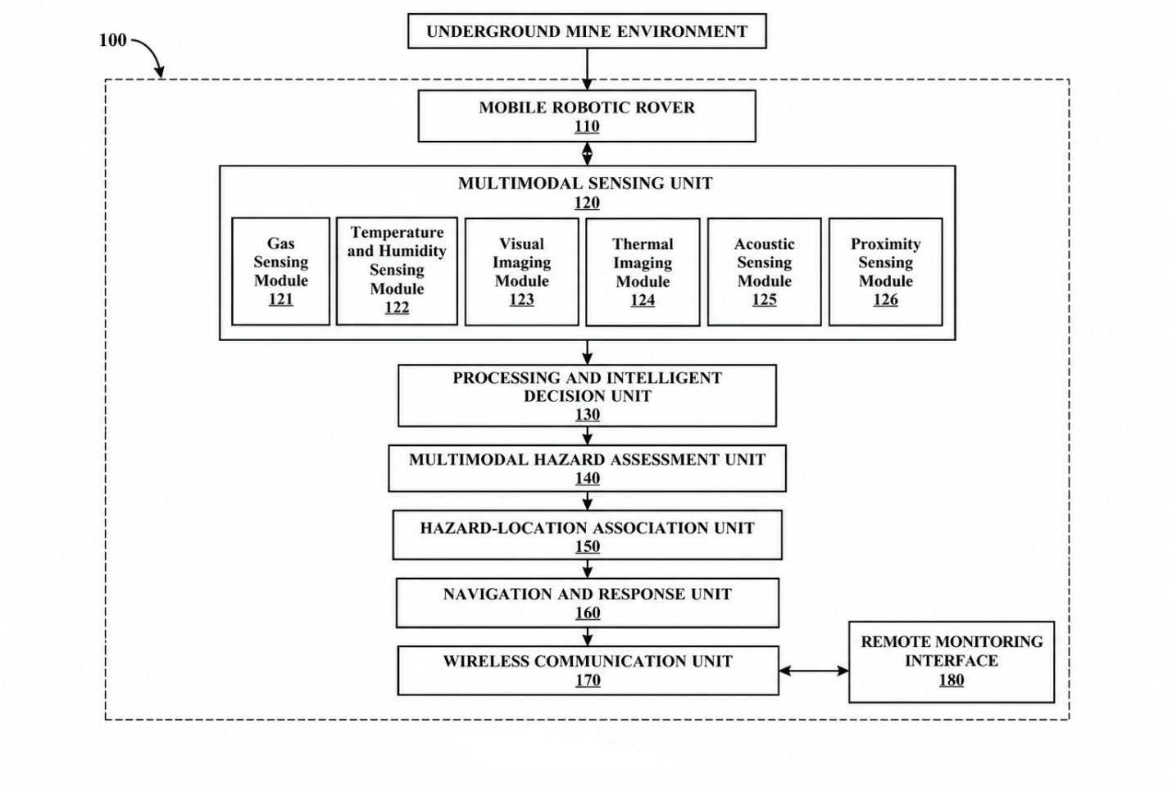
FIG. 1A — Overall System Architecture
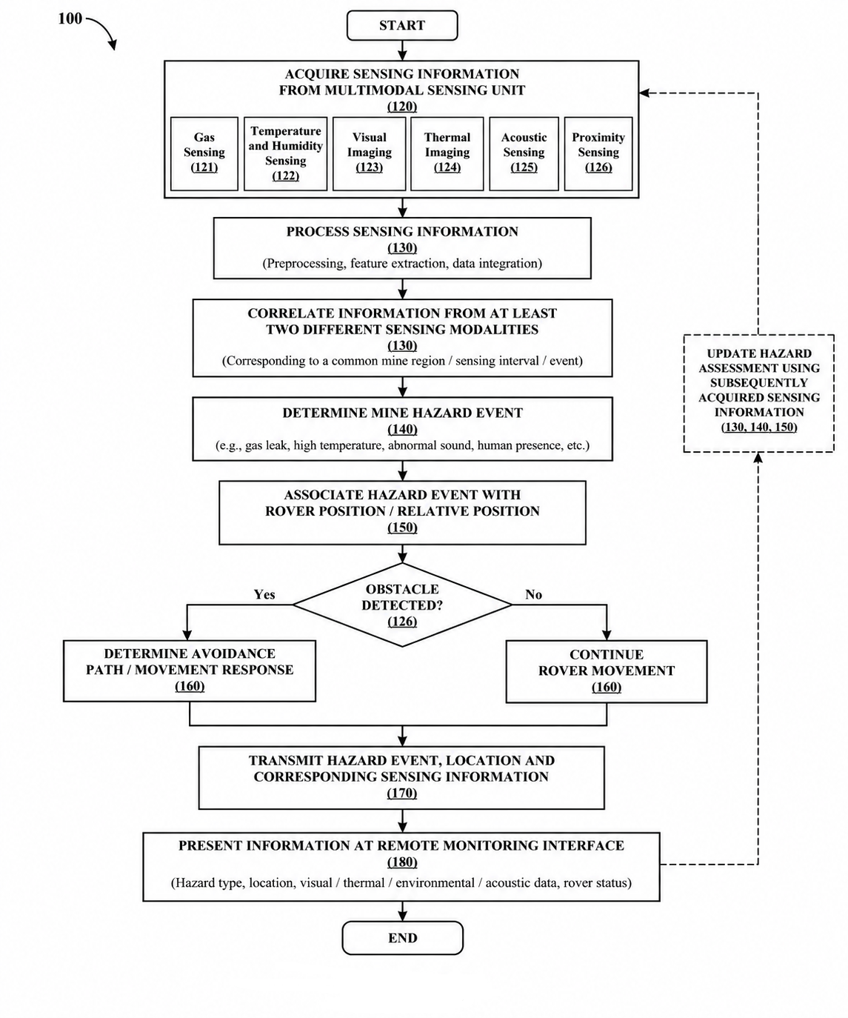
FIG. 1B — Functional Operation Architecture

